TASK-3
PART A- Coding Practice
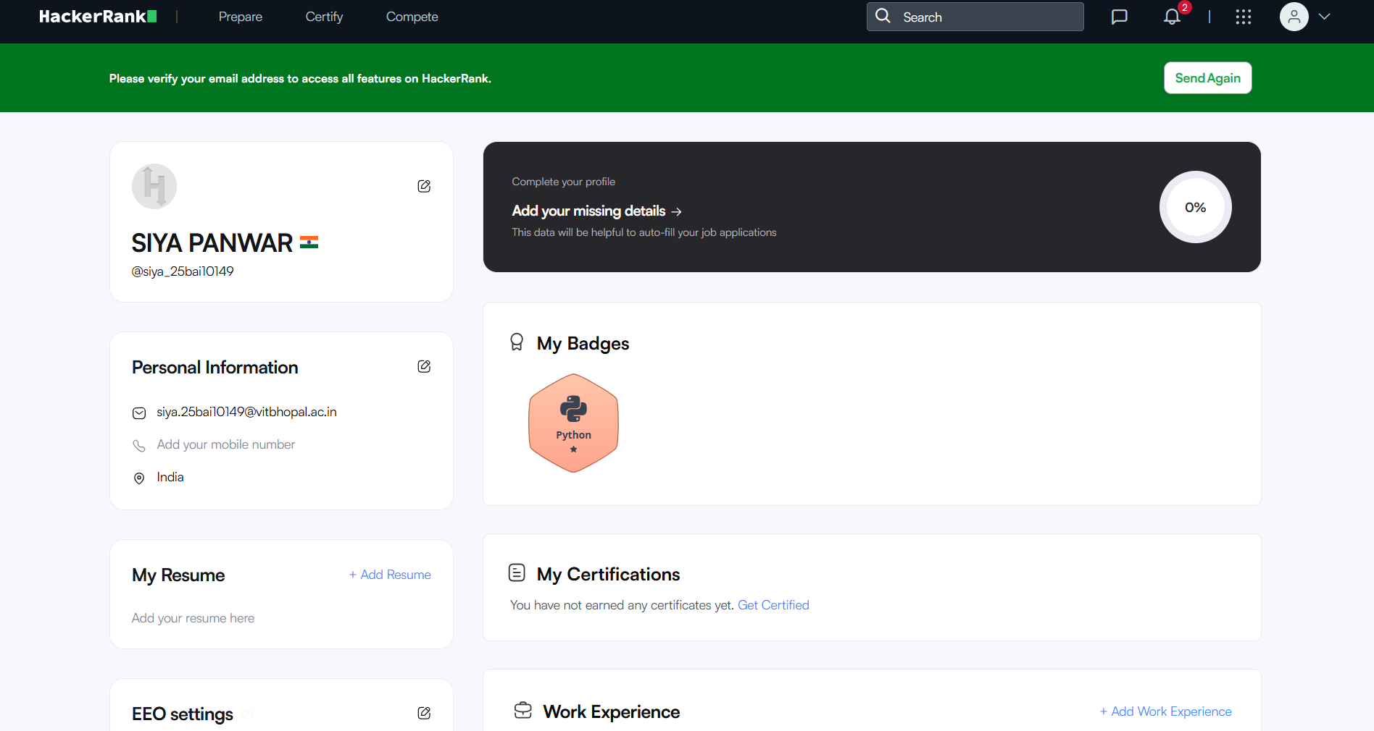

PART B- Google Workspace Collaboration
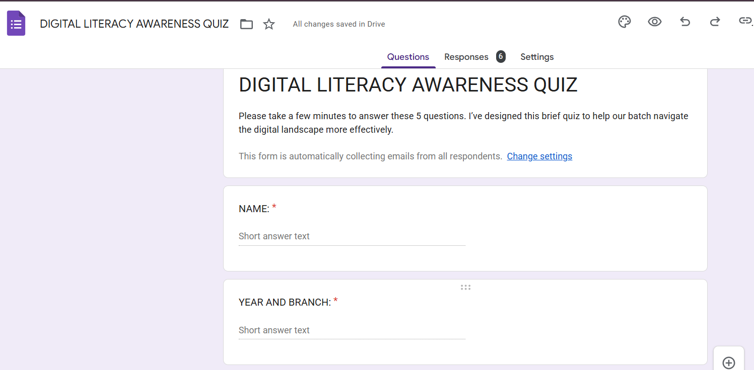

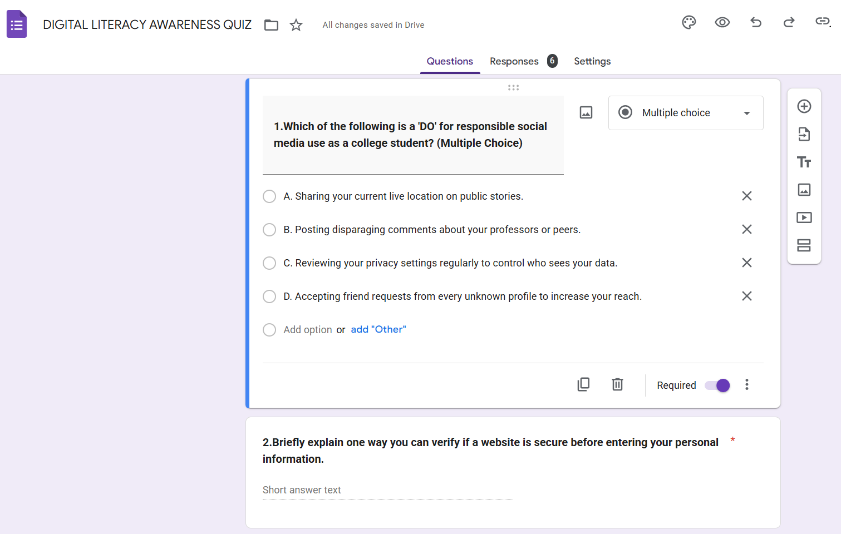

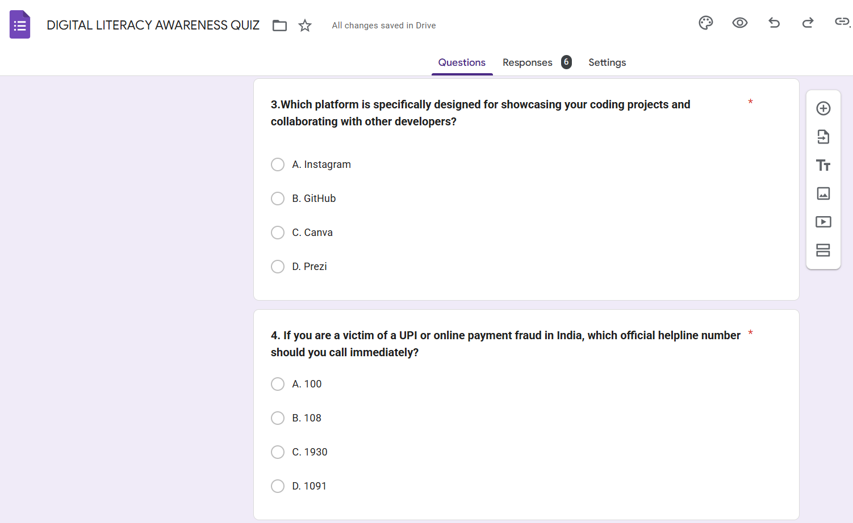

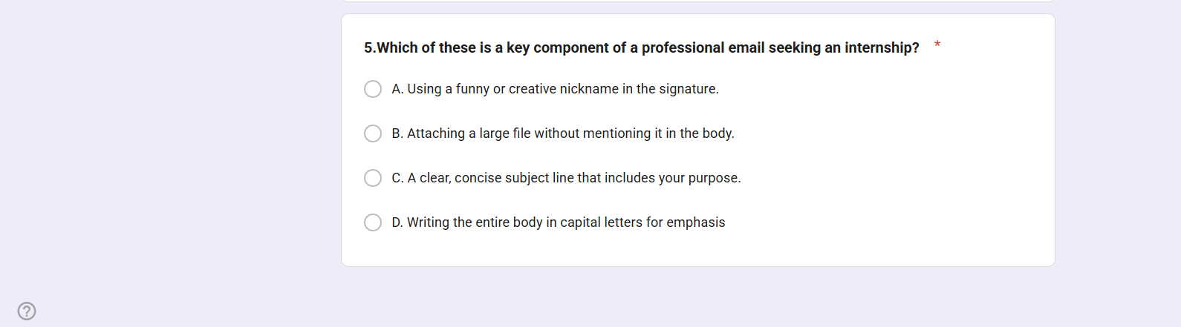
https://docs.google.com/forms/u/0/d/e/1FAIpQLSfWt0DOeikQBqHz-ltQpWQTJY_iboYqwBMR1qSYcVgK0qT8fw/formResponse?pli=1

RESPONSE SHEET
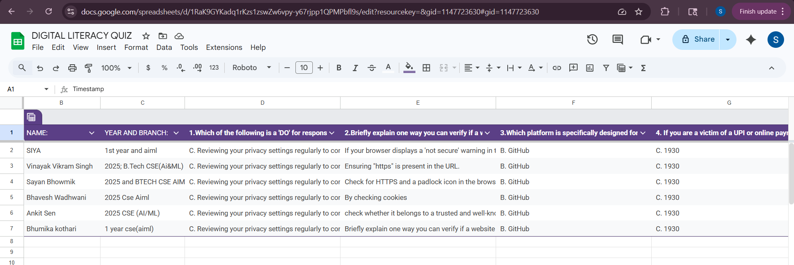
https://docs.google.com/spreadsheets/d/1RaK9GYKadq1rKzs1zswZw6vpy-y67rjpp1QPMPbfl9s/edit?resourcekey=&gid=1147723630#gid=1147723630

